Thesis

Table of Contents

1. 1 Introduction 7

1.1 The need for TTE: 7

1.1.1 The use of the underground medium 7

1.1.2 TTE research and commercialization 8

1.1.3 VLF communication approach 10

1.2 Electromagnetic analysis of VLF band 10

1.2.1 Transmission coefficient 10

1.2.2 Magnetic Versus Electric Radiators (Gibson p.47, high speed p.219). Near field 11

1.2.3 Magnetic Radiator: non conducting medium Field expressions (Gibson p.47 13

1.2.4 Magnetic Radiator: Conducting medium Field expressions 13

1.2.5 Skin effect 15

1.2.6 Antennas 19

1.3 Channel model: Brazil figure 14 21

1.4 Noise model (Gibson p.158) 21

1.5 The choice of OFDM 21

1.5.1 Analog or FSK ( Brazil, p. 166) 21

1.5.2 MSK (Brazil [2]) 21

1.5.3 impulsive noise (Brazil); frequency selective? 21

1.5.4 No good model. (Brazil p.170 left) 21

1.5.5 OFDM is flexible both on Tx and on Rx 22

1.5.6 CSIT is of advantage 22

1. 2 System, Magnetic and analog devices 23

2.1 System requirements 23

2.1.1 Throughput 23

2.1.2 Range 23

2.1.3 Antenna 23

2.1.4 Frequency domain characteristics 23

2.1.5 Direction sensitivity 23

2.2 SIMO 1x3 23

2.2.1 Ordinary use of SIMO: small scale fading 23

2.2.2 Proposed use of SIMO: Large scale fading 23

2.3 SDR concept 23

2.4 Magnetic devices 23

2.4.1 Tx 23

2.4.2 Rx 23

2.5 Analog devices 23

2.5.1 D/A 23

2.5.2 A/D 23

2.5.3 Reconstruction & Anti-aliasing filters (Maxim) 23

2.6 Link budget 23

2.6.1 Calculation 23

2.6.2 Simulation 23

1. 3 OFDM - General 25

3.1 Need: Rx & Tx Selectivity 25

3.2 Evolution of OFDM 25

3.2.1 FDM 26

3.2.2 Analog OFDM 26

3.2.3 Digital OFDM 27

3.3 Mathematical representation 27

3.3.1 Tx 27

3.4 Mathematical representation 27

3.4.1 Tx 27

3.4.2 Rx: matched filtering as FFT 29

3.4.3 Rx: matched filtering as FFT 29

3.5 CP: 29

3.5.1 General: Frequency domain equalization- Linear into cyclic convolution 29

3.5.2 OFDM frequency domain equalization: flatness per subcarrier (channel=complex scalar) 29

3.5.3 Preservation of orthogonality 29

3.5.4 ISI (Guard time) 29

3.6 Time synchronization problems: effect on signal (Prasad) 30

3.7 Frequency synchronization problems: effect on signal (Prasad, NPTEL, my summary) 30

3.8 Pilots 30

3.9 Guard bands: 30

3.9.1 The need to D/A 30

3.9.2 the DC sc 30

3.10 Preambles 30

3.10.1 Long: 30

3.10.2 Short: 30

1. 4 OFDM –parameters calculations 30

4.1 CP 30

4.2 N FFT 30

4.3 Length of preambles 30

1. 5 Transmitter 31

5.1 Preambles enhancement 31

5.2 PAPR reduction 31

5.3 Analog HW compensation: inverse sinc, differentiator 31

1. 6 Receiver: 32

6.1 Equalizer types (see findings document) 32

6.2 Timing synchronization 32

6.3 Frequency& phase synchronization 32

6.4 MRC MIMO 32

1. 7 Data Converters integration: 33

7.1 Setting the Fs, Frec 33

7.2 Synchronization 33

7.3 Frequency error effect on signal integrity. My analysis (summary) and results 33

1. 8 Results- Simulations 34
2. 9 Results- Field experiments 35
3. 10 References 35
4. Signal processing for through-the-Earth radio communication, Raab& Joughin 35

Table of figures

# Introduction

## The need for TTE:

### The use of the underground medium

Using the underground medium as a valid part of the battlefield is not unique to the recent years. Tunnels have served the Vietnamese in the Vietnam War both as a shelter and a stealth base to launch attacks against the American military. In Korea, one of the most probable scenarios to which the South Koreans and their counterparts are preparing for is an invasion launched from tunnels dug beneath the border between the two hostile states. Yet, the most actual case is the Israel-Gaza border where the tunneling warfare occupies a major role on both sides; Hamas on the attacker side and Israel on the defending side. It has reached a point where an entire all out clash’s outcome depends mainly on the underground warfare. As a result, huge technical and financial efforts are put to outrank the rival.

On the Homeland Security area, the underground medium has a presence too. Emergency services, often need to penetrate into closed underground spaces where no communication infrastructure is present such as collapsed buildings. Also in that domain, is the problem of illegal infiltration through the Mexico-USA border, where tunnels are sometimes used.

Yet, probably the area where the underground medium is most present is the civilian. The mining industry has suffered for hundreds of years from a bad reputation for its high rate of accidents and fatalities. Very often the accident itself is the cause for a communication failure which is usually wired. Recently, there is an interest in autonomous mining equipment [Brazil], requiring 2-way communication for operation and control.

In all of these cases, we are facing the need for a reliable wireless ad-hoc communication ability.

### TTE research and commercialization

Despite the old and proven need for Surface to Underground TTE wireless communication, up until late 2010’s, no such commercial nor military communication system had been developed. The capability of low frequency (ULF-VLF band) Electromagnetic Fields to penetrate through the ground has been proposed as early as 1890 by Nikola Tesla [Carrol]. However, in the 1970’s a research conducted by the US Bureau of Mines suggested that the required transmitted power, namely on the underground side, should exceed the safety allowable levels, thus making it impractical. [NIOSH].

From the 1970’s and on, there was only very little research in the field. Raab & Joughin suggested a signal processing techniques adapted to the VLF band on 1995, but only as late as mid 2000’s, after the launch of the semi commercial American NIOSH program we were able to witness more intensive research in that field (Raab, Brazil, Brakand& Damiano …), aiming to evaluate the channel characteristics (Brazil, 2016), and noise (Raab, 2010)

The advances in the communication technology from the 1990’s and on, namely the digital communications, digital signal processing and coding techniques, offered enhanced receiver performance allowing reduction of the transmitted power. A sponsored study was initiated by the American National Institute for Occupational Safety and Health (NIOSH) on 2007, in which participated 5 contractors: Lockheed Martin, E-spectrum, Stolar and Alertek. Its aim was to examine the feasibility of TTE wireless communication in the mining industry. All but one (E-Spectrum) adopted the Magnetic field approach: large Loop antennas (Coils in fact) communicating through a Quasi-Static Magnetic Field. The Magnetic field approach systems reached a distance varying between 180m to 300m with antenna diameters varying between 1.2m to 90m. For all 5 contractors, actual performance was significantly lower than what they had initially predicted. One reason is the fact that they had employed techniques borrowed from radio frequency communication systems, that may not fit the actual VLF channel impairments. A second one, is the fact that the noises evaluated during the researches of the 1970’s and 1980’s are probably much less intensive than those nowadays, mainly the man-made type. [NIOSH, p.6 left bottom]. Although not mentioned (apart from Ultra and Alertek), it seems and is quite logical view the time when the design took place, that most if not all contractors used standard single carrier techniques (FSK for Ultra and Alertek)

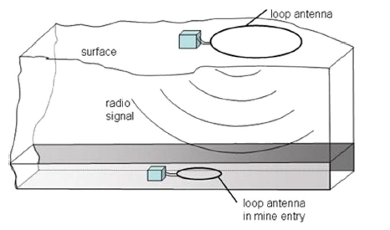

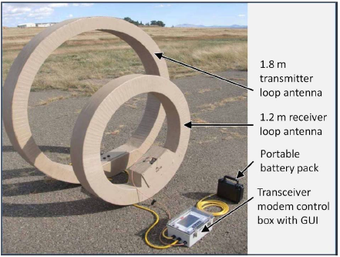

### VLF communication approach

## Electromagnetic analysis of VLF band

### Transmission coefficient

A typical TTE link involves a surface based station residing in the free air and an underground station. The ground is not a homogenous and may be composed of several mediums that are conductive in general.

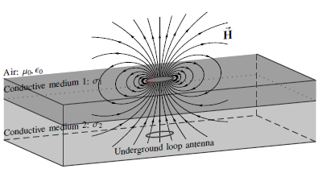

Suppose we transmit from the surface into the ground, the electric and magnetic fields will experience a reflection at the mediums’ boundary followed by an exponential decay with distance other than the polynomial decay already experienced in the non conductive medium.

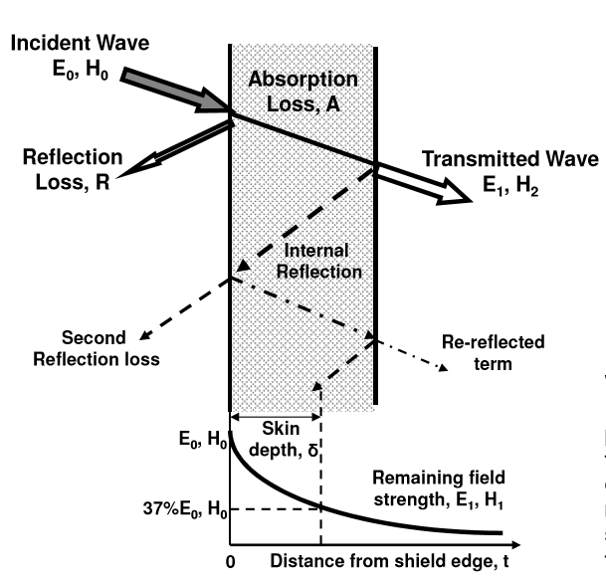

The ratio between the incident and transmitted fields is

Where Z is the wave impedance of the medium. Assume that the air’s impedance is close to the free space’s (at far field);

The ground’s (conducting medium) impedance is calculated as follows

(see Clemmow, An introduction to ….section 5.3.2)

Where the , are the ground’s permeability (which is similar the free space’s; ) and conductivity. Example; for ,

The , and the transmission coefficient is

### Magnetic Versus Electric Radiators (Gibson p.47, high speed p.219). Near field

Free space wave impedance, in the above equations, is dependent on the radiator type and on the distance from it normalized by the wavelength. For a good (high) transmission coefficient we would need a low free space impedance.

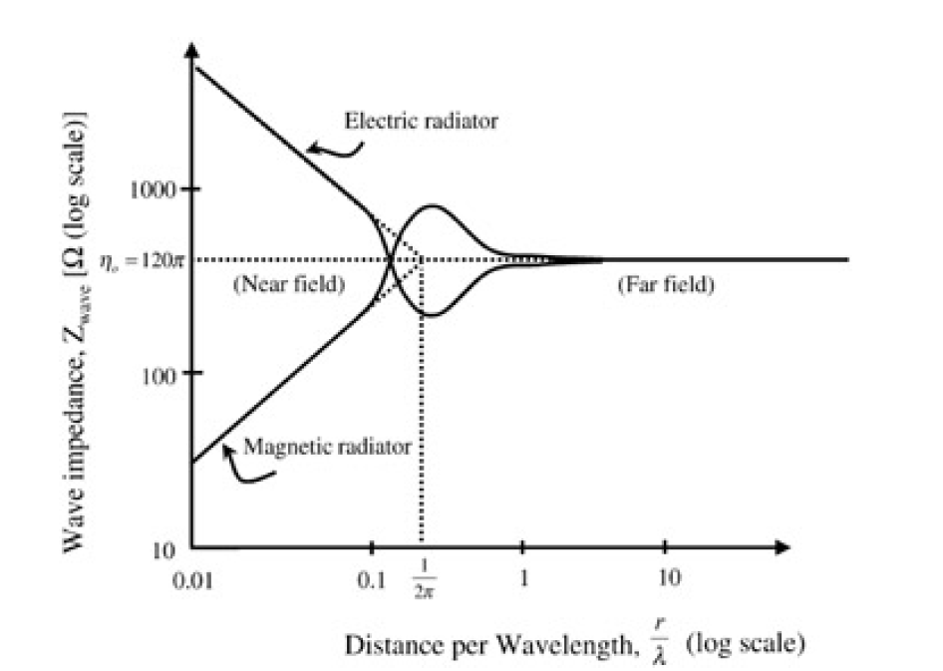

For that to occur, the source needs to be a magnetic radiator and the boundary placed at a low electrical distance from the source

(p.219, High speed… )

Electric and magnetic radiators mentioned above are the electric and magnetic dipoles

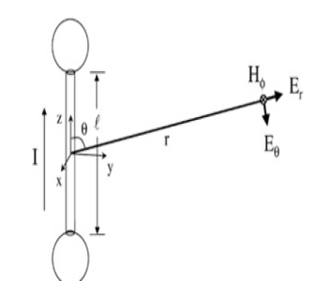 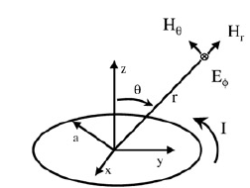

Example: for a conducting medium with , and the boundary placed at () the (extrapolated from 0.01 at a rate of /5 per decade) The Transmission coefficient this time will be: .

In these 2 facts resides the concept of the TTE communication: a magnetic radiator operating in the near field, or equivalently- in the Very Low Frequency band. Another reason for operating on low frequencies is treated in greater details later on.

The term “Magneto Quasi Static communication” originates from the radiation source and the frequency band and not from the communicating fields. The magnetic radiator generates both magnetic and electric field.

### Magnetic Radiator: non conducting medium Field expressions (Gibson p.47

The EM fields emitted by a small loop antenna are:

If we define, and is the wave number. then;

### Magnetic Radiator: Conducting medium Field expressions

#### Complex wave number

The magnetic induction expression above was derived from;

Where is the magnetic vector potential function. As with all other functions, scalars and vectors, involved in Maxwell’s equations, it is also the solution of a wave equation:

(is the current density field vector). is the wave number and is defined:

In a conducting material we replace with , which leads to the following definition of the wave number on conducting medium;

. is the skin depth and will be discussed in greater detail later.

#### Complete expressions (2-18)

With the definition;

#### Far field approximation ( 2-20)

Under the assumption that , we could express the EM fields with:

Looking at the magnetic induction, we can see that in the near field it points to both radial and tangential directions, and as the distance increases, the tangential takes over the radial to become fully tangential in the far field

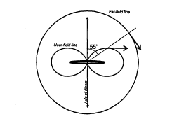

### Skin effect

In previous section we introduced the term . It appeared in the expression of the fields inside a conductor both in the complex and the real exponentials’ power. The accurate expression is:

But it is less useful than its approximations:

A good conductor: ,

A poor conductor: ,

Example: A medium with ,

#### Wave number interpretation

The term corresponds to the phase of a plane wave with a wave number of

#### Attenuation factor interpretation

The term means an attenuation of the field amplitude at an exponential rate of . the range at which the attenuation reaches 8.7dB is called the “skin depth”. The exponential term becomes dominant the further we are from transmitter. In this zone, we can say that the signal is attenuated by 8.7dB at every skin depth.

#### Near field motivation of the TTE

The field amplitude versus the normalized range is shown below

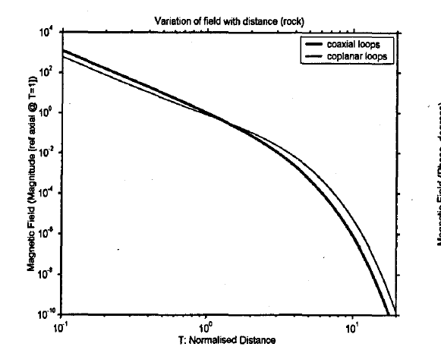

In the expression of the field, the normalized range appears in inverse cube form at the denominator and as an exponential power. We can see that from about and on, the field amplitude attenuation is dominated by the exponent; the “skin effect” (Gibson p.56 bottom). This attenuation is far more intensive than the one caused by the inverse cube, thus motivating us to operate the TTE link in the “short distance” zone dominated by the inverse cube.

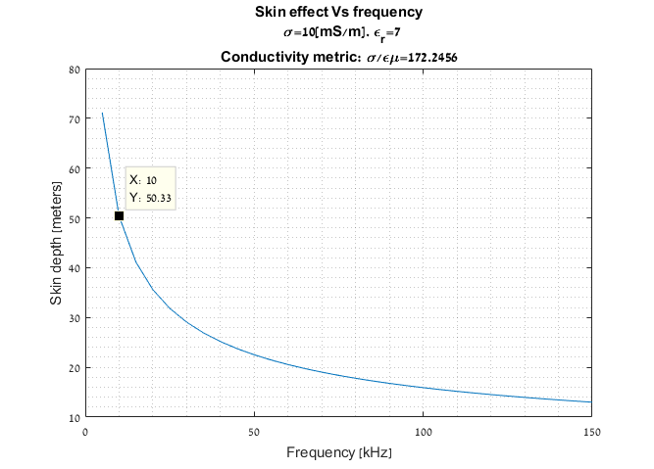

In the case of the curve above, at 10kHz we can be assured to be in the “inverse cube zone” at least up till 50m depth.

This fact is the 2nd main motivation for operating the TTE links in the near field, which corresponds to the VLF band

#### Ground as a conductor (p.54-55)

The conduction and the eventually the skin depth of a given medium depend of the material conductivity ( , permittivity () and permeability (). In general, the bigger of the material, the more it is conductive and the smaller is the skin depth. For communication purposes we are interested in operating in the inverse cube region of the field for as large distances as possible, thus, in large skin depths.

The conductivity of the soil can vary from to , depending on the moisture level. The factor of the permittivity () can vary between 7 and 43. The permeability of most materials does not vary much from that of the free space..

The following figure illustrates those dependencies.

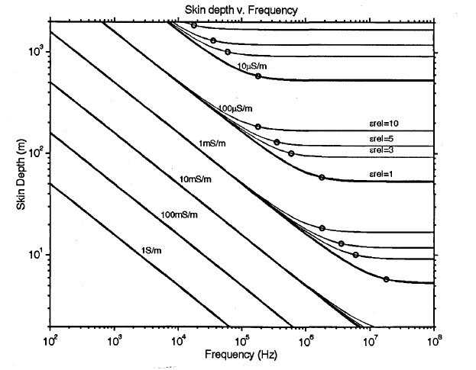

#### Magneto quasi static & near field (Gibson, p.58)

Some of the literature claim that we should distinguish between the Magneto Quasi Static and Near Field zones.

The Quasi Static zone is defined as the distance from source where the condition holds. The expression of the field in that zone is (H without loss of generality):

We can see that it depends on range merely by an inverse cube relation.

The Near Field zone is where the skin depth exponential decay begins to have an effect. That zone comprises the distances where the condition holds. The field expression there is:

We can see that it resembles the complete expression apart from the term.

#### Wavelength in conducting materials

We already saw that the wavenumber of a signal in a good conducting material was (Gibson 2-15);

Since ,we can say that , which means that the wavelength in a conductor much shorter than its free space value.

example; . The , which derives that . In free space, , which means a ratio of more than 30.

### Antennas

#### H-field and E-field antenna (p.102)

We must remember that both magnetic and electric radiators produce both magnetic and electric fields. Moreover, despite the fact that an electric radiator suffers from large attenuation at the air medium-conductive medium boundary, it may not be fully ruled out as a possible radiator. Varying the mutual positioning of the radiators could couple all field types from Tx antenna to Rx antenna .Hence, theoretically all 4 Tx-Rx combination ( H->H, E->E, H->E, E->H) are possible choices. The issue is treated in Gibson (chapter 4) that refers to Clemmow; the analysis presented there treats the SNR at the receiver antenna and not only the coupled signal. We will not bring the full reasoning, but summarize that the most natural combination is that of H-field antennas on both sides of the link.

#### Antennas orientation (Gibson 48, 49-50

Based on the magnetic field expression we can draw the following field lines diagram

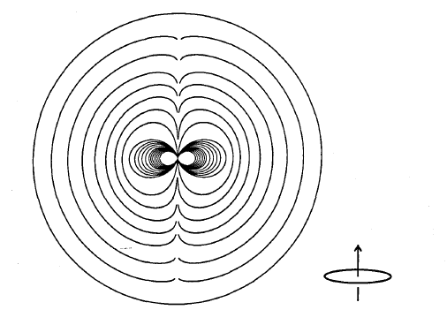

That diagram suggests that magnetic field coupling will exist in both co-axial and co-planar mutual positioning

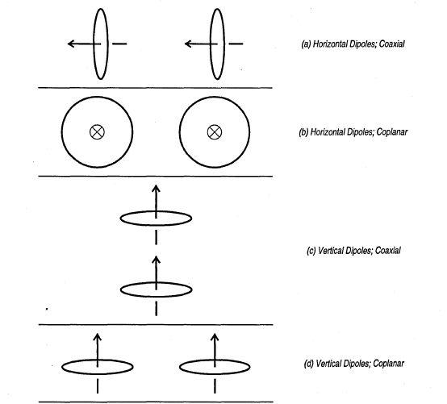

A deployment of a TTE link will look as follows

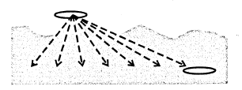

#### From current loop to solenoid

The term , the magnetic moment, has appeared in the magnetic induction expression produced by a Tx antenna. Its value for a N windings solenoid is:

Where N is the number of turns, I is the current flowing in the solenoid and A is the Solenoid area.

## The choice of OFDM

The choice of the waveform to be used in the TTE communication system is a substantial issue. It should be the result of the multiple considerations:

* Channel model
* Noise model
* Required throughput
* Required distance
* Available spectrum
* Available HW and signal processing resources

We have chosen to use the Orthogonal Frequency Multiple Access (OFDM) technique and the reasoning is brought below

### Channel model: Brazil figure 14. No good model. (Brazil p.170 left)

#### Multipath

The issue of wavelength inside a conducting material was discussed earlier; it is much lower than free space wavelength. However, if we remain in the quasi-static or near field areas (close to transmitter), we can be assume that the link, Transmitter-Channel-Receiver, represent a lumped system. i.e; a system whose electrical length is much lower than the quarter of wavelength, whose spatial phase almost does not vary between the 2 circuit edges. This practically eliminates the possibility of multipath propagation [Spain, Gibson 2.4.3]. Nevertheless, it does not say that the channel may not be frequency selective.

#### Optimum Frequency (Gibson 2.2.4)

Only few literature (e.g; Brazil, Spain, Gibson) has treated the subject.

[Gibson] claims that on one hand the Electromotive force induced upon the Rx loop by the transmitted magnetic field is proportional to frequency. On the other hand, the conducting medium’s attenuation is also proportional to frequency. Therefore, we should expect a bandpass like shape of the frequency response. The peak is a solution of an optimization problem and achieved at , i.e at

[Brazil] attempted to develop an analytical model, regarding the channel as a trans-admittance transfer function, achieving the same result as [Gibson]

Continue form here

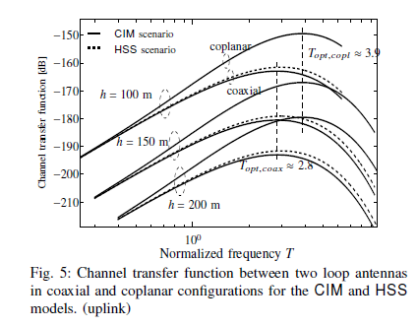

[Spain] suggested a measurement method and actually performed it. Their

### Noise model (Gibson p.158). impulsive noise (Brazil); frequency selective?

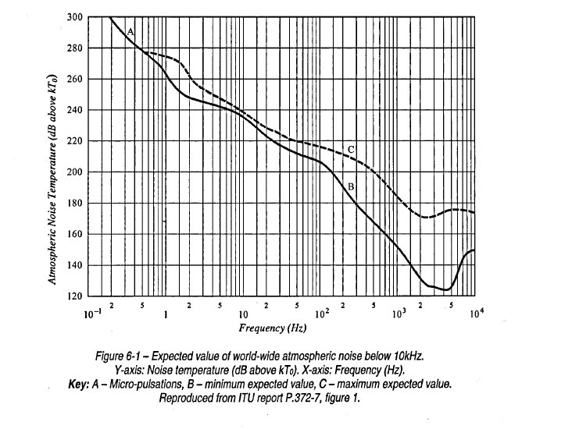

### TTE communication waveforms

### Techniques Analog or FSK ( Brazil, p. 166). MSK (Brazil [2])

### OFDM is flexible both on Tx and on Rx

Innovation: To our knowledge, none of the commercial manufacturers use OFDM. Enables frequency selective modulation and coding, what fits the still unknown TTE channel noise and shape. [NIOSH p.2 left up]

Severe channel selectivity limits the bandwidth if single carrier techniques are used. OFDM decouples the sub carriers and therefore….

High sensitivity to mutual antennas orientation. We developed a 1x3 SIMO with 3-axis Rx antenna to prevent that, sensitivity (at least on the Rx side) namely for a moving object [NIOSH p.2 left middle

### CSIT is of advantage

# System, Magnetic and analog devices

## 

## System requirements

### Throughput

### Range

### Antenna

### Frequency domain characteristics

### Direction sensitivity

## SIMO 1x3

### Ordinary use of SIMO: small scale fading

### Proposed use of SIMO: Large scale fading

## SDR concept

## Magnetic devices

### Tx

### Rx

## Analog devices

### D/A

### A/D

### Reconstruction & Anti-aliasing filters (Maxim)

## Link budget

### Calculation

### Simulation

# OFDM - General

## Need: Rx & Tx Selectivity

Along the years, communication systems have been challenged to provide higher data rates, to operate in increasingly difficult channel mediums and in increasingly densely occupied spectrum. The NLOS channels, in particular, confronted the communication system with highly frequency selective channels. All of the above created the need to provide waveforms with inherent frequency flexibility allowing both Tx and Rx chain to process the signal in frequency selective manner. The traditional single-carrier technology did come up with means of dealing with these impairments, with equalizers fora example, but this ability was limited to moderately selective channels and frequently did more harm than good

## Evolution of OFDM

OFDM and its ancestors are based on simultaneous transmission instead of serial transmission. A single carrier signal can be expressed as follows:



Where  is the pulse shaping function (usually belonging to the Raised cosine family),  is the n’th data symbol, and  is the symbol time. The separation between the consecutive symbols is in the time domain, and the pulse shaping function is such that enables the extraction of a given symbol form its predecessors and followers.

A multicarrier waveform is expressed as follows:



Where  are called the “sub-carrier” functions and are the data symbols, and  is again the symbol time. Here, the separation is achieved in the frequency domain

Naturally, in order to transmit the same amount of data symbols;



Hence, we can regard the multi carrier subcarriers as independent single-carrier waveforms, each spanning along a much longer duration in time that their corresponding true single carrier waveform. Longer duration means narrower bandwidth, which suggests why multi carrier waveforms deal better with frequency selective mediums.

### FDM

The basic waveform contains several sub carriers spectrally separated from each other. i.e; concatenated in such a way that a simple amplitude (e.g; brick wall, butterworth) filter bank can extract them with no significant loss of energy:

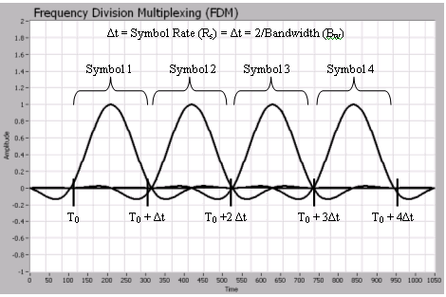

The implementation, however, is rather cumbersome and complex as it requires a bank of analog filters, frequency sources and mixers.

### Analog OFDM

Orthogonal FDM uses the orthogonal Fourier basis for as the subcarrier family. That allows a denser arrangement, hence a better spectral efficiency

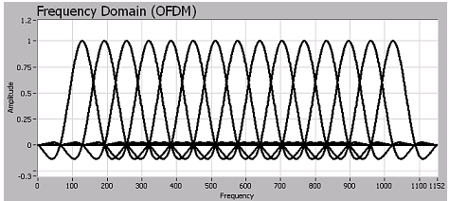

The analog implementation remains cumbersome

### Digital OFDM

The digital implementation of OFDM solves that problem of complexity of implementation as the simultaneous modulation/demodulation operations becomes IDFT/DFT operations. Those are naturally realized via the particularly efficient IFFT/FFT algorithms.



## Mathematical representation

### Tx

Additionally, it makes use of the DFT’s cyclic convolution property to easily estimate the channel and efficiently correct it.

## Mathematical representation

### Tx

the complex Fourier basis is:



i.e; a family of functions completing an integer number of cycles within the time span 



The transmitted signal, which is the linear combination of that basis with a QAM symbols stream as coefficients will be:



Will turn to:



The following figure demonstrates that procedure:

The symbol stream: multiplied by the above basis functions gives (real part)



Which look meaningless

### Rx: matched filtering as FFT

### Rx: matched filtering as FFT

## CP:

### General: Frequency domain equalization- Linear into cyclic convolution

### OFDM frequency domain equalization: flatness per subcarrier (channel=complex scalar)

### Preservation of orthogonality

### ISI (Guard time)

## Time synchronization problems: effect on signal (Prasad)

## Frequency synchronization problems: effect on signal (Prasad, NPTEL, my summary)

## Pilots

## Guard bands:

### The need to D/A

### the DC sc

## Preambles

### Long:

* + - 1. PN sequence

### Short:

* + - 1. Channel estimation
      2. SNR estimation

# OFDM –parameters calculations

## CP

## N FFT

## Length of preambles

# Transmitter

## Preambles enhancement

## PAPR reduction

## Analog HW compensation: inverse sinc, differentiator

# Receiver:

## Equalizer types (see findings document)

## Timing synchronization

## Frequency& phase synchronization

## MRC MIMO

# Data Converters integration:

## Setting the Fs, Frec

## Synchronization

## Frequency error effect on signal integrity. My analysis (summary) and results

# Results- Simulations

# Results- Field experiments

# References

[1]

D. Gibson, “Channel characterisation and system design for sub-surface

communications,” Ph.D. dissertation, School of Electronic and Electrical

Engineering, 2 2003

Through the Earth Communications for Underground Mines. Carreno, Silva et al

[2] NIOSH – sponsored Research in Through the Earth Communications for Mines: a status report

Through the Earth Mine Communication systems. NIOSH

[3]

Through the Earth Communications: Breathrough solution for Miner safety. Carrol Technology group

# Signal processing for through-the-Earth radio communication, Raab& Joughin

High-Speed Digital System

Design—A Handbook of

Interconnect Theory and Design

Practices

**Amplitude-Probability Distribution Model for**

**VLF/ELF A tmospheric Noise (Field& Lewinstein)**